|  |
| --- |
| MODULE CONTROL |

Now we have a working CRUD interface for our system, it’s time to look at the things that the Admin interface on our sidebar can do. For starters, there’s Cobalt’s Module Control interface.

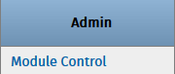

In the Module Control page we can enable or disable sections of the system as necessary in order to restrict users from accessing them. This is the highest-level restriction that can be imposed on your system as disabling modules practically renders them unusable by the system until re-enabled.

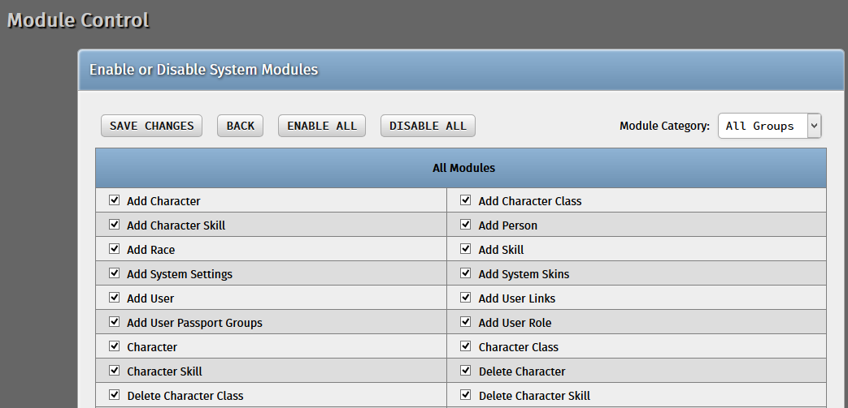

**DISABLING MODULES**

To see how it works, let us try disabling a module – uncheck the “Add Character” checkbox. This will disable adding new characters into the system. Click “Save Changes” afterwards.

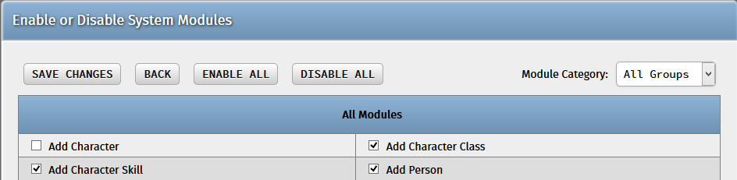

Now try accessing the “Character” page. You will find that the “Add new record” link has disappeared.

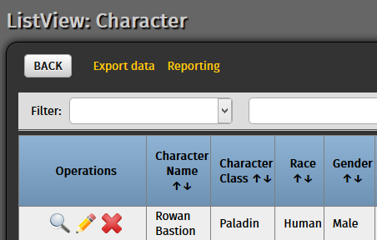

Trying the direct link to the “Add New Character” function (<http://localhost/rpg_char_system/modules/character/add_character.php>) will result into the error below. This action will log you out of the system so just log back in.

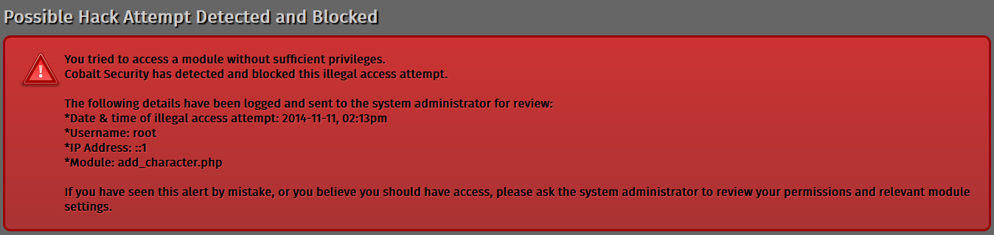

**ENABLING MODULES**

Enabling the module is as simple as checking the checkbox once again. Don’t forget to click “Save Changes”!

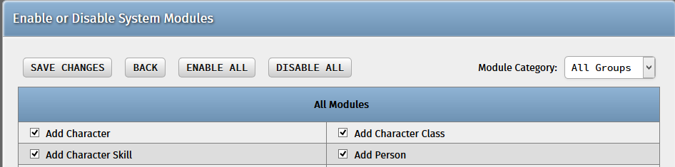

Navigate back to the “Character” page and you will find that the “Add new record” link has returned to its proper place.

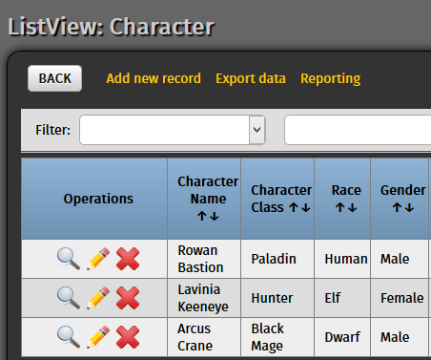

**COBALT MODULES**

By default, Cobalt generates four modules for each database table – Add, Edit, View, and Delete. Customized links and pages that you will generate later on may also be included here to be enabled / disabled. Also, the Module Control feature even works on other Cobalt Admin functions as well!